***Part 1 Pseudocode:***

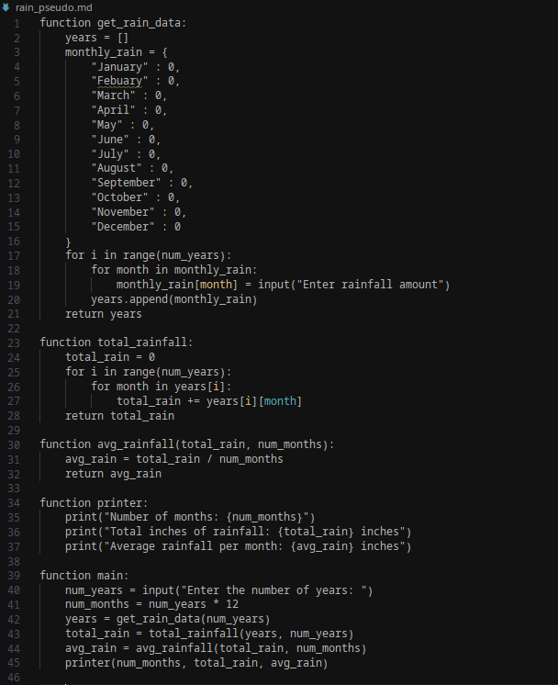

***Part 1 Source Code:***

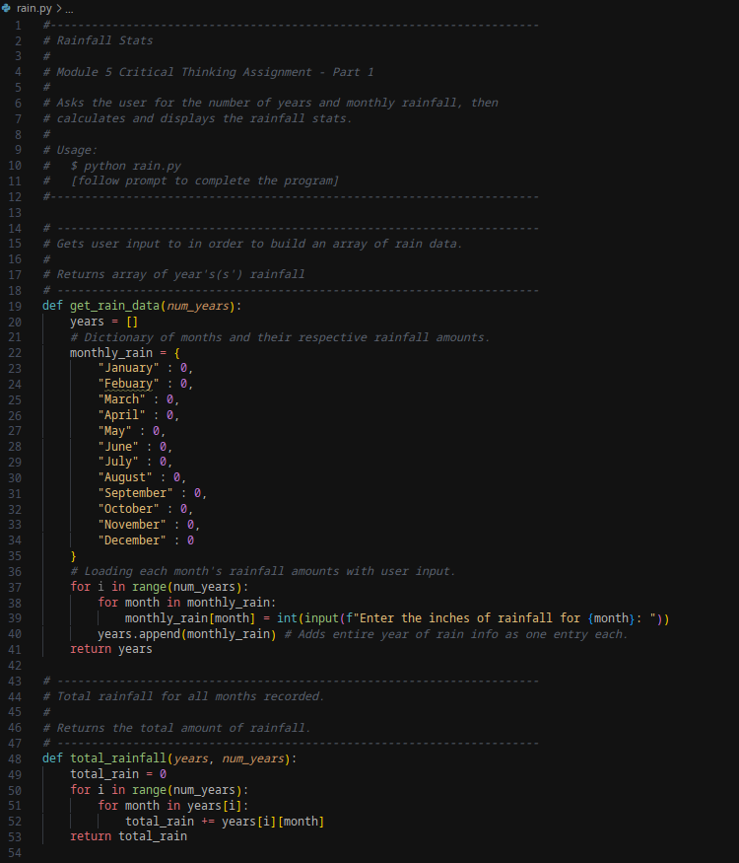

***Part 1 Source Code Continued:***

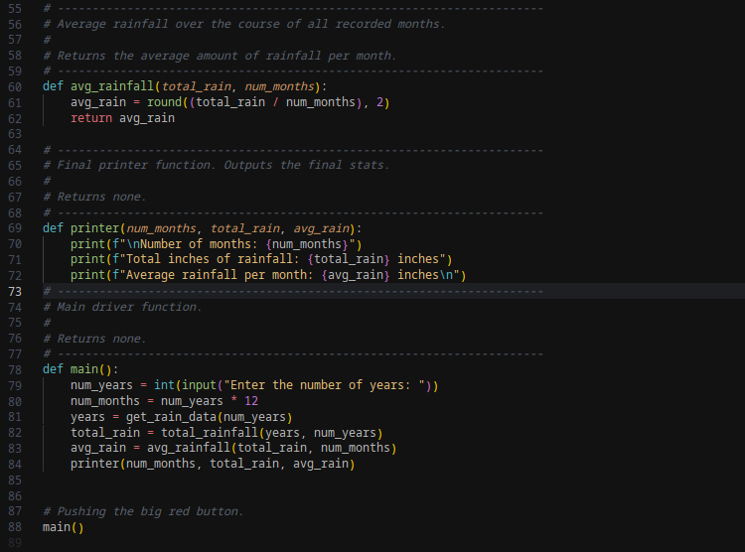

***Part 1 Output:***

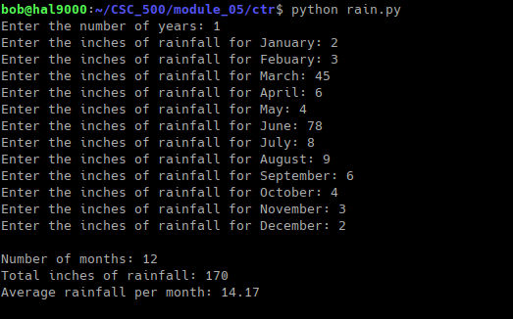

***Part 2 Pseudocode:***

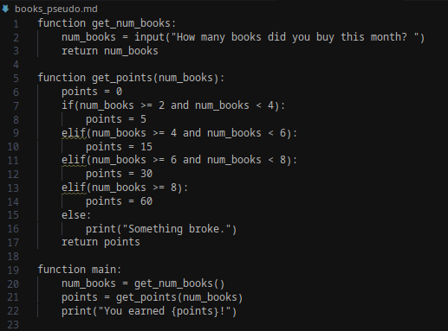

***Part 2 Source Code:***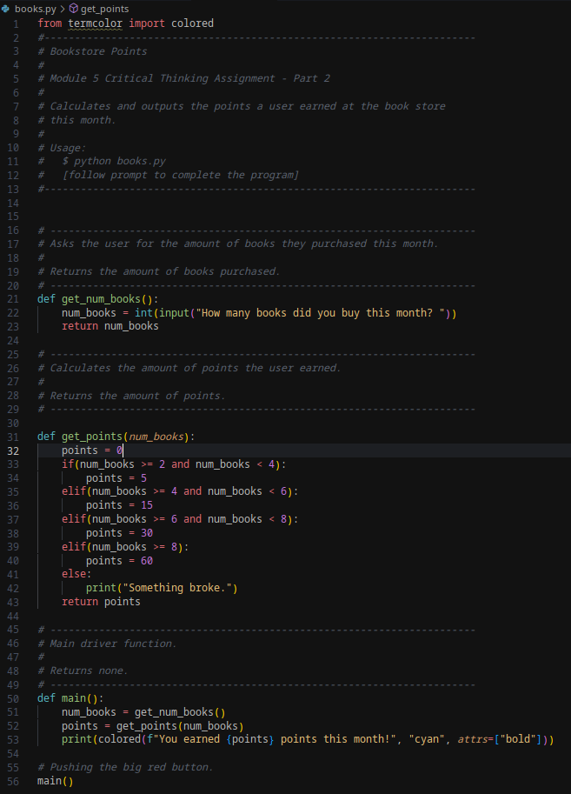

***Part 2 Output:***



[***Github Repo***](https://github.com/rt75272/CSC_500/tree/main/module_05/ctr)***:***

https://github.com/rt75272/CSC_500/tree/main/module_05/ctr